**Advance Excel Assignment 5**

1. How many types of conditions are available in conditional formatting on Excel?

Different Types of Conditional Formatting in Excel

1. Highlight Cells Rules
2. Cell Value Is Greater Than Particular Value
3. Cell Value Is Lesser Than Particular Value
4. Cell Value Between Two Values
5. Cell Value Is Equal to Particular Value
6. Cell Containing Particular Text
7. Cell Containing Particular Dates
8. Duplicate Cell Values
9. Top and Bottom Rules

a) Top Values from Data Set

b) Top 10% Values from Data Set

c) Bottom Values from Data Set

d) Bottom 10% Values from Data Set

e) Above Average Values of Data Set

f) Below Average Values of Data Set

1. Data Bars
2. Color Bars
3. Icon Sets
4. How to insert border in Excel with Format Cells dialog?

Below is the step to insert border in Excel with Format Cells dialog.

1. First, select the dataset A1:C4 where you need to create a border.
2. Then, go to the home tab.
3. Now, click on the Font Settings from the Font group.
4. In turn, a Format Cells dialog box will pop up.

1. Here, go to the Border tab.
2. After that, choose the line style and color from the style and color option successively.
3. Next, in the Borders section, choose a Preset option or apply borders individually.
4. Finally, click OK.
5. How to Format Numbers as Currency in Excel?

Follow the below step to format numbers as currency in excel.

1. Select the cell you want to change the format number as currency in excel like B2:B4.
2. Press Ctrl + 1 to open Format Dialog Box.

1. In the first tab Number under category select currency.
2. If you want to select specific currency like dollar you do that from Symbol option.
3. After select the specific currency click OK button.
4. What are the steps to format numbers in Excel with the Percent style?
5. Select the cell you want to change the format number as currency in excel like B2:B4.
6. Press Ctrl + 1 to open Format Dialog Box.

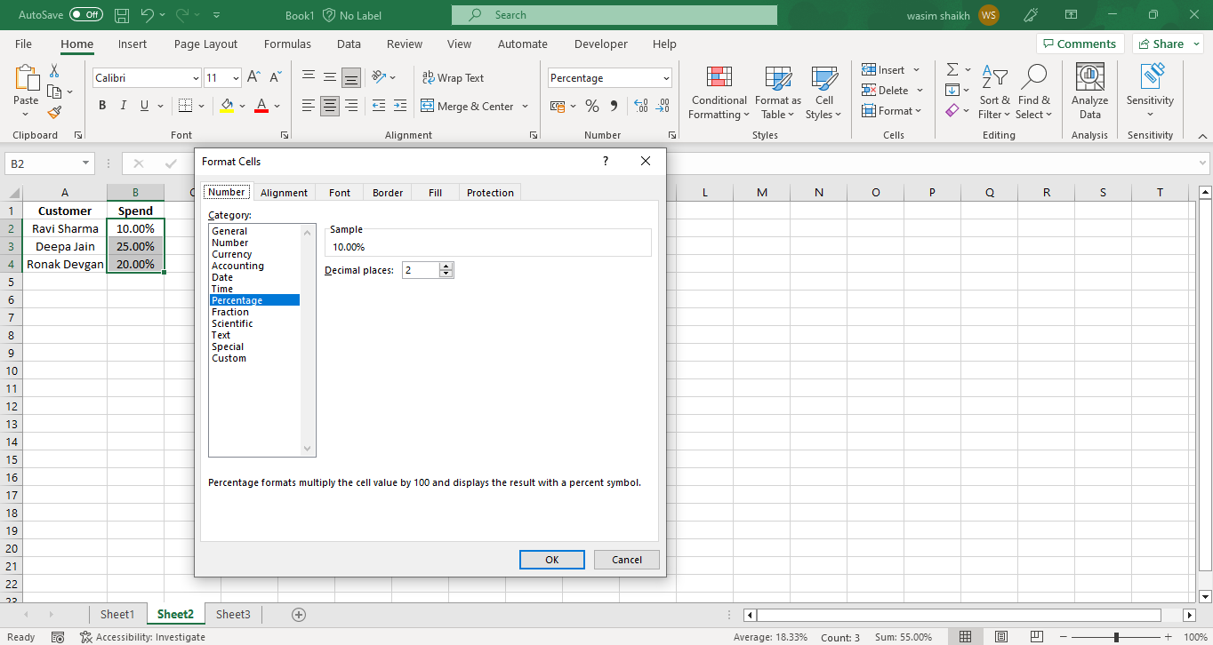

1. In the first tab Number under category select Percentage.
2. You can select percentage and change the decimal with 2-digit places.
3. Select OK button and the new Percentage style will be applied.
4. What is a shortcut to merge two or more cells in excel?

Short cut key to merge two or more cells is press Alt + H + MM

1. How do you use text commands in Excel?

We can use text commands in excel for various purposes and below are some of the mentioned criteria.

1. ARRAYTOTEXT
2. ASC function
3. BAHTTEXT function
4. CHAR function
5. CLEAN function
6. CODE function
7. CONCAT function
8. DBSC function
9. DOLLAR function
10. EXACT function
11. FIND, FINDB
12. FIXED
13. LEFT, LEFTB
14. LEN, LENB
15. LOWER
16. MID, MIDB
17. NUMBERVALUE
18. PHONETIC
19. PROPER
20. REPLACE, REPLACEB
21. REPT
22. RIGHT, RIGHTB
23. SEARCH, SEARCHB
24. SUBSTITUTE
25. TEXT
26. TEXTAFTER
27. T
28. TEXTBEFORE
29. TRIM
30. UNICHAR
31. UNICODE
32. UPPER
33. VALUE
34. VALUETOTEXT